Vaibhav Shikshan Sanstha

College of Education (B. Ed), Vita.

Tal- Khanapur Dist-sangli

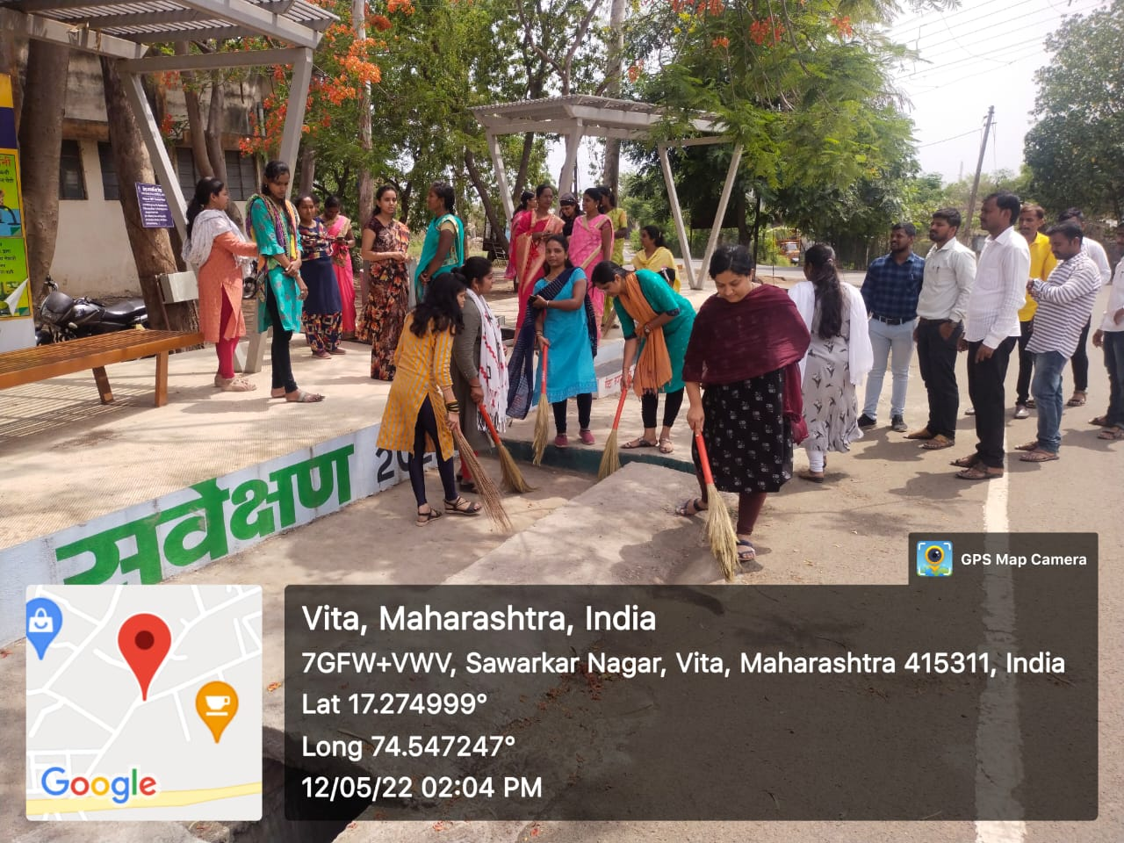 **Social Service**

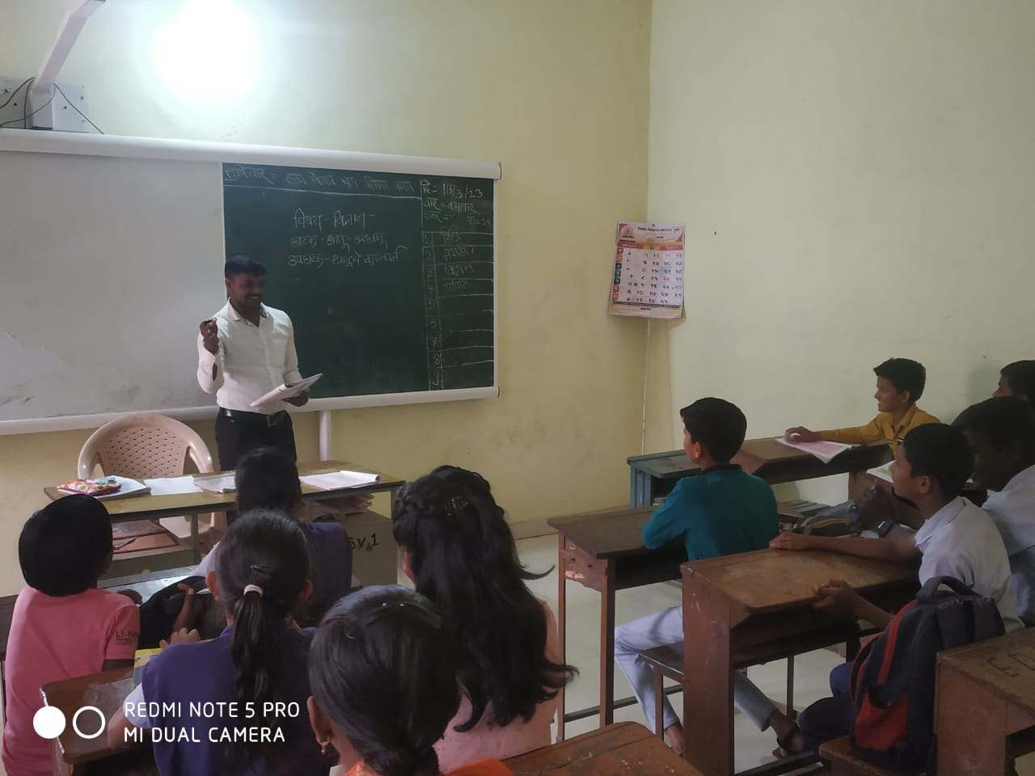 Practice lesson

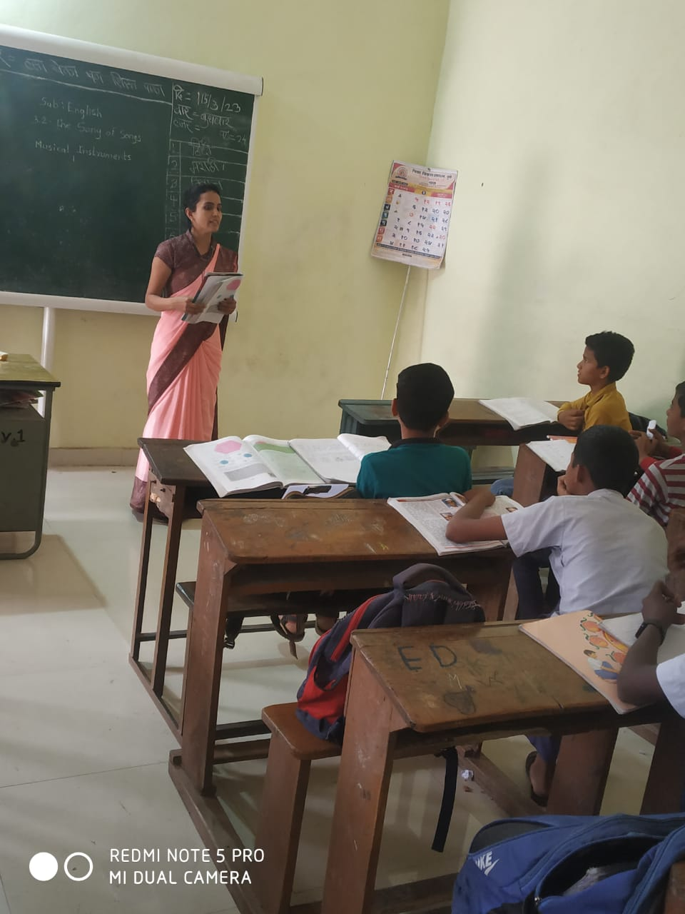

Vaibhav Shikshan Sanstha

College of Education (B. Ed), Vita.

Tal- Khanapur Dist-sangli

Internship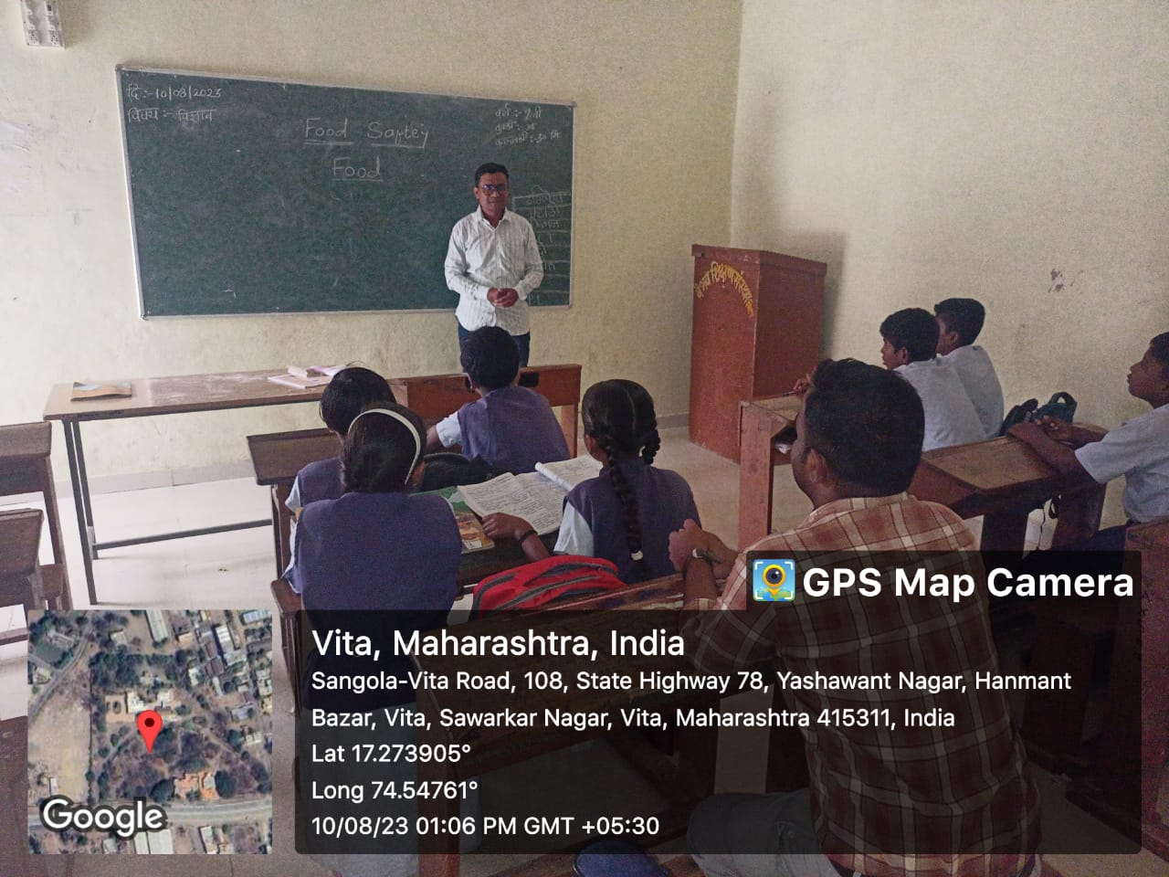

Workshop on Enhancing Teaching Skills

